UI UX
Assignment 1
Soham Pawar
Roll No 71
PRN:1032240061
Panel D2

Audible Critical Analysis

Audible is an audiobook and spoken-audio platform used for discovering, purchasing, and listening to audiobooks. The application provides a professional interface, but certain navigation and content discovery features can be improved.

1.⁠ ⁠Learnability
Audible is relatively easy for first-time users to understand. The Library and playback controls use familiar terminology and icons. However, the relationship between membership benefits, credits, purchases, and included content may initially confuse new users.
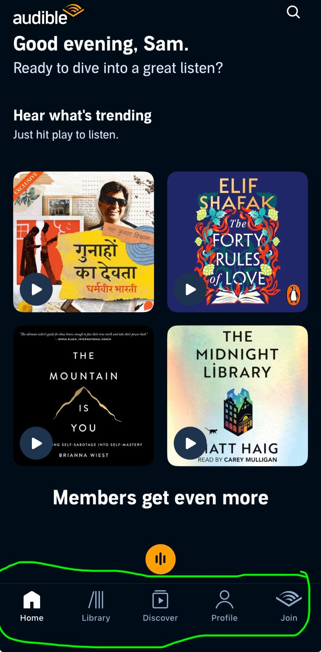
2.⁠ ⁠Usability
Listening to an audiobook from the Library is simple. Playback features such as speed control, chapter selection, bookmarks, and sleep timer are useful. However, discovering whether a book is included with membership or requires a separate purchase can increase user effort.
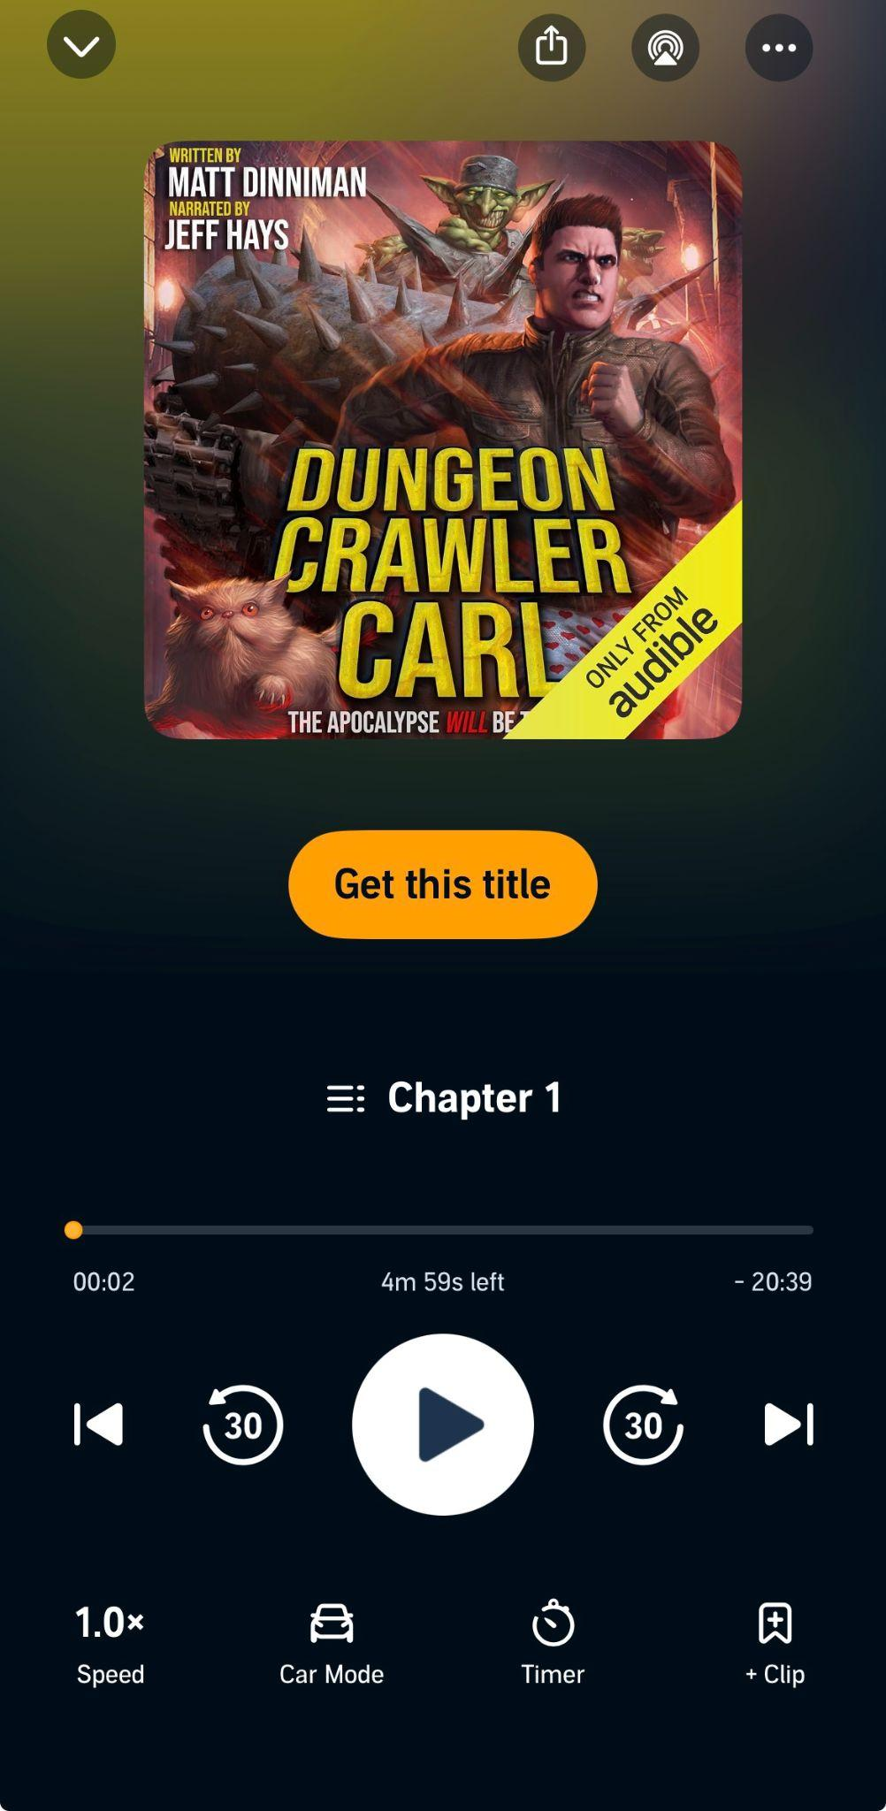

3.⁠ ⁠Consistency
Audible maintains consistent typography, colours, icons, and audiobook card designs. The player interface also remains visually consistent. However, different content types and purchase options may display different actions, which can create confusion.
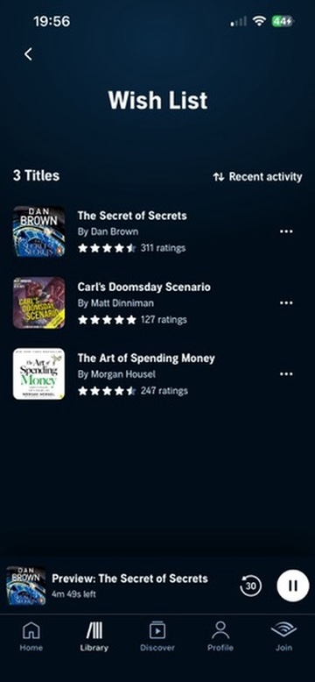

4.⁠ ⁠Use of Metaphors
The application uses familiar metaphors such as a book for Library-related content, a magnifying glass for search, a bookmark for saving a listening position, and standard play and pause controls. The sleep timer also represents a familiar real-world timer concept.
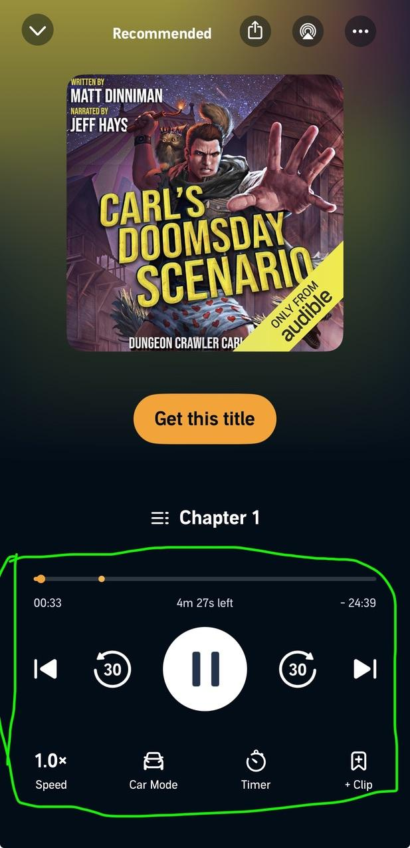

5.⁠ ⁠Navigation Structure
The main sections are logically organised. However, users may need to move between the Home screen, Library, Discover section, and audiobook detail pages to complete simple discovery tasks. The content hierarchy can be simplified.


6.⁠ ⁠Visual Hierarchy
Audiobook covers and titles are given high visual importance. The play button and listening progress are clearly visible. However, promotional recommendations and membership-related information may compete with the user’s personal Library content.
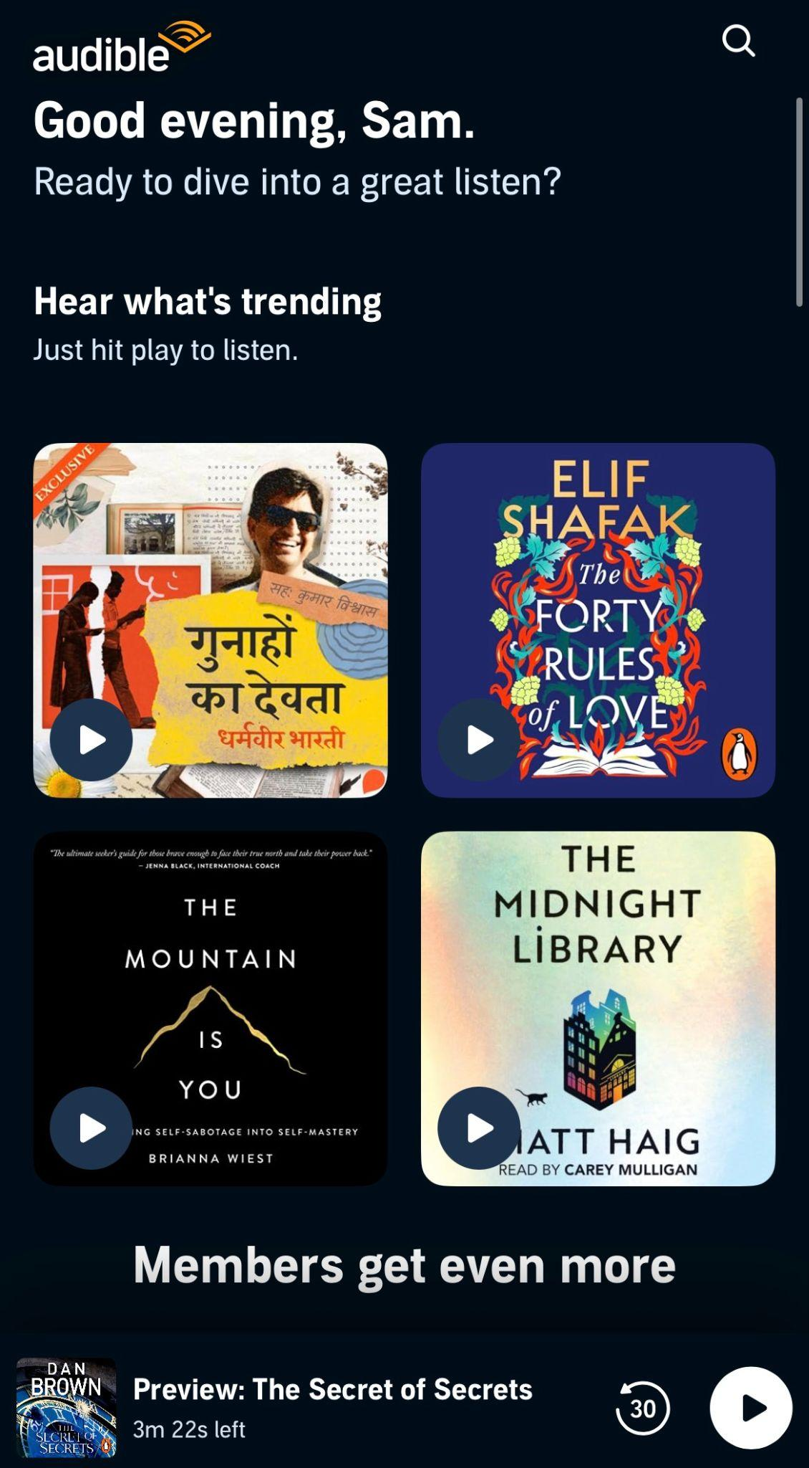

7.⁠ ⁠Accessibility
Audible provides clear playback controls and readable typography. Playback speed controls can support different listening preferences. However, some secondary text and smaller interface elements may be difficult for users with visual limitations.


8.⁠ ⁠Responsiveness
The application works effectively on mobile devices, while Audible’s interface is also accessible on larger screens. The mobile player is designed appropriately for touch-based interaction.

9.⁠ ⁠Efficiency of Interaction
Once an audiobook is in the user’s Library, playback requires very few steps. Features such as bookmarks and sleep timers are directly available from the player. However, content discovery and purchase-related decisions may require additional steps.
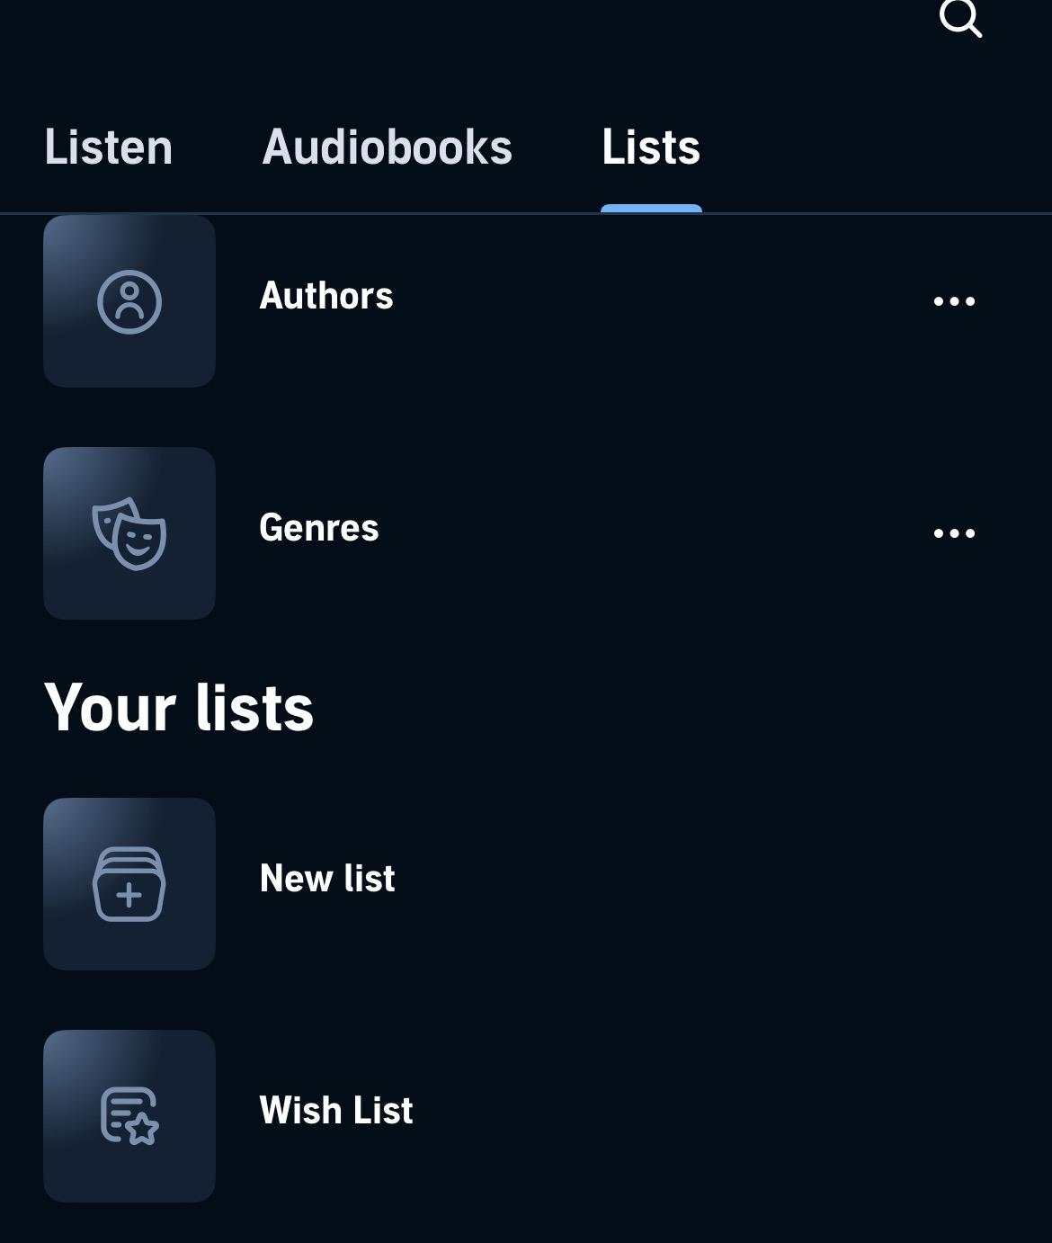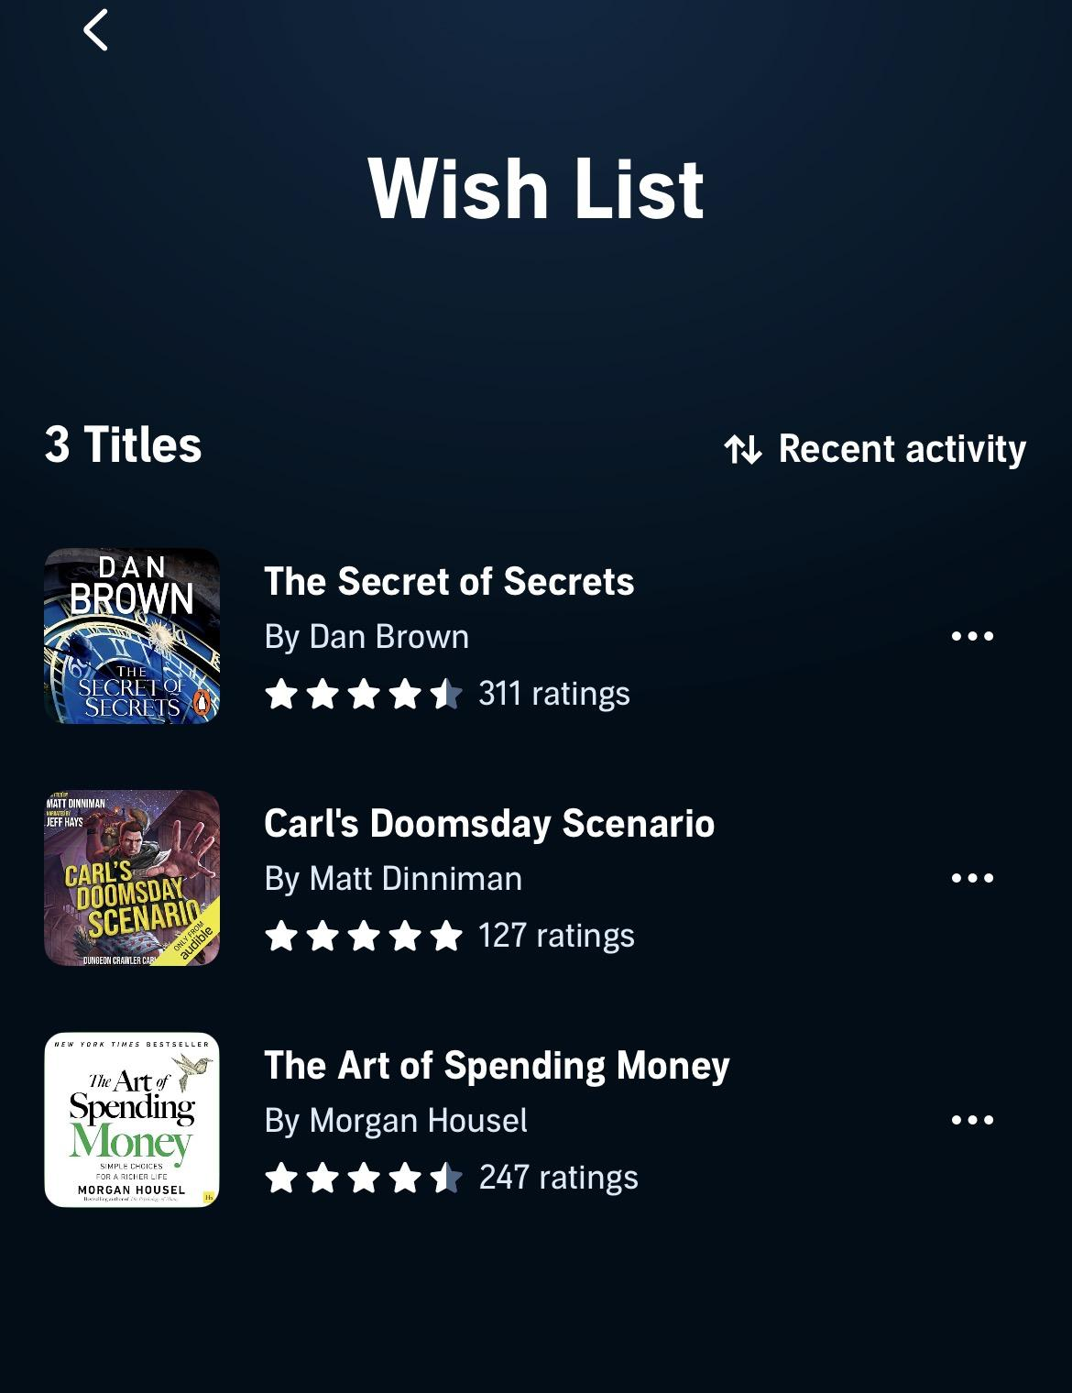

10.⁠ ⁠Feedback and System Status
Audible clearly displays listening progress, remaining time, chapter information, download status, and playback speed. These features provide continuous feedback to the user.


11.⁠ ⁠Error Prevention and Recovery
Bookmarks help users save important positions in an audiobook. The application also remembers listening progress. However, some Library management actions could provide clearer confirmation or undo options.

12.⁠ ⁠Aesthetic and Minimalist Design
Audible has a professional and visually appealing interface. Audiobook covers are effectively used as visual elements. However, promotional content and recommendations can make the Home screen appear busy.

13.⁠ ⁠Content Readability
Book titles, authors, narrators, and listening information are generally readable. The separation of content information is effective. However, audiobook descriptions can be lengthy and may require improved formatting for faster scanning.
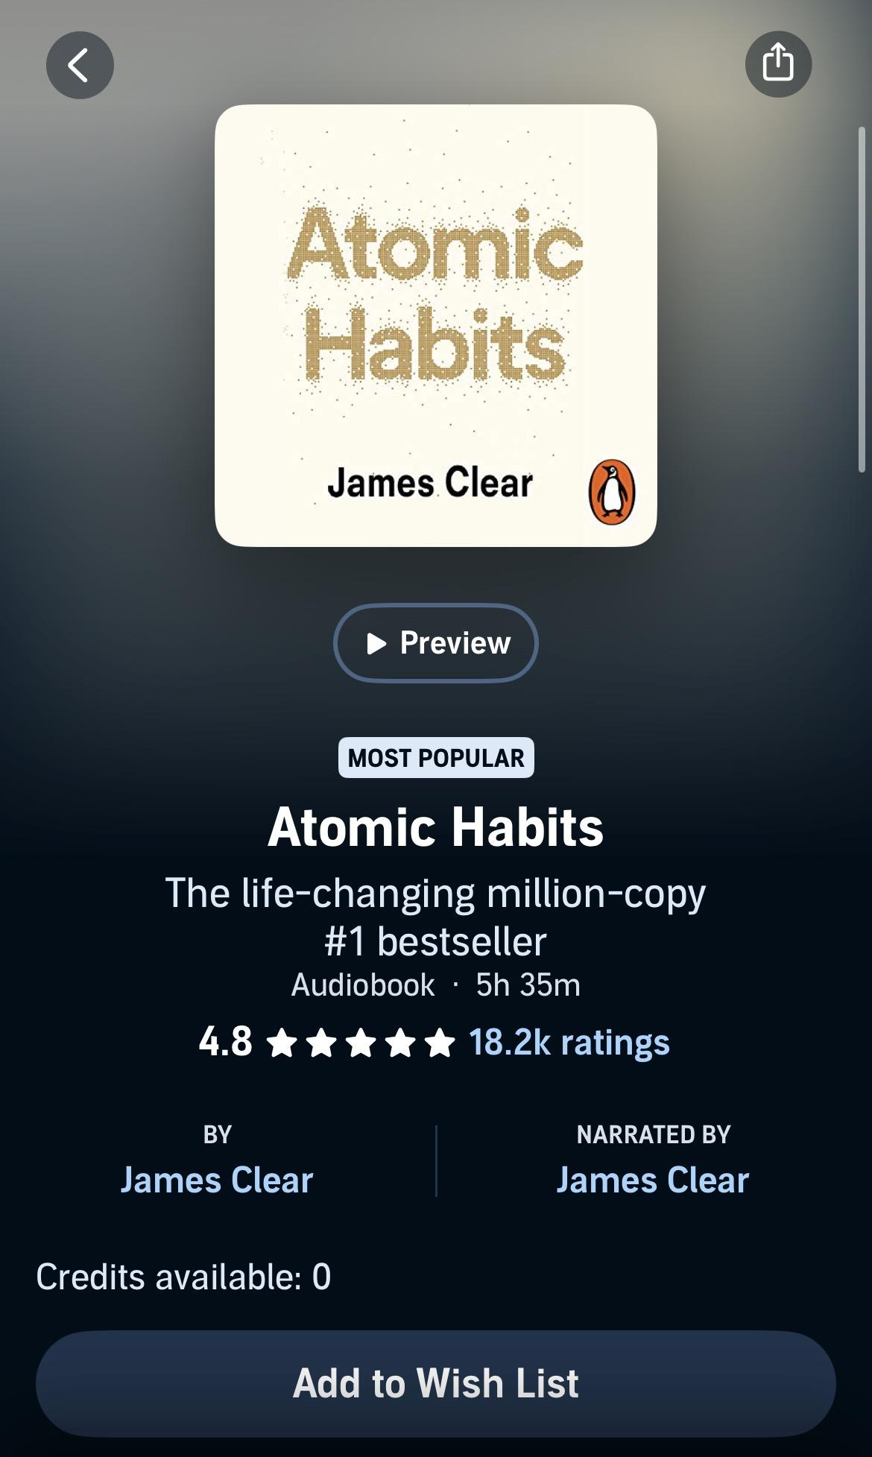

14.⁠ ⁠Search and Discoverability
Users can search using book titles, authors, and other keywords. Categories and recommendations improve discovery. However, filters for quickly identifying content based on duration, membership availability, or narration preferences could be more prominent.
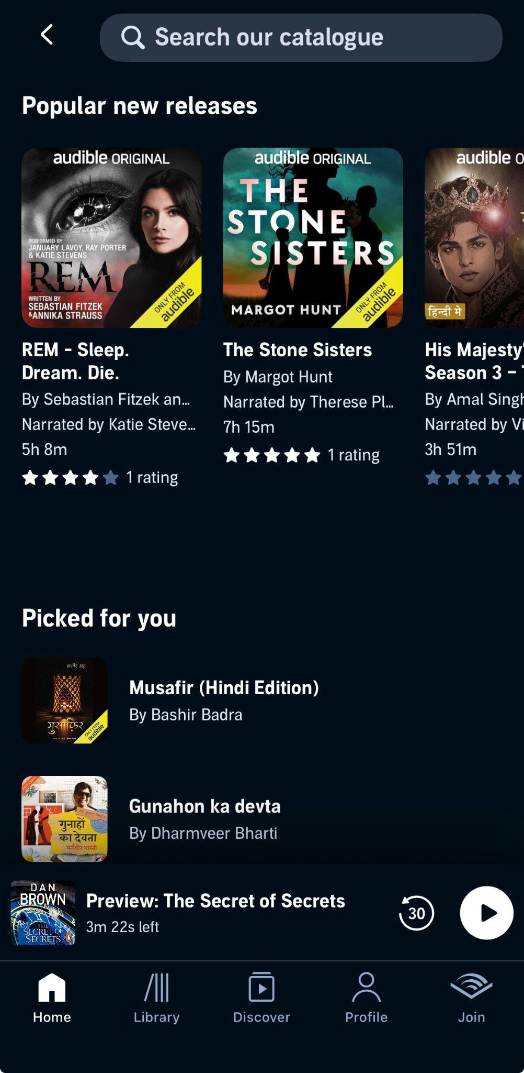

15.⁠ ⁠Performance Perception
Download indicators and playback progress provide a clear understanding of system activity. Downloaded audiobooks also provide a smooth listening experience.

16.⁠ ⁠Trust and Credibility
The professional interface and clear presentation of authors, narrators, ratings, and audiobook details create credibility. Account and purchase information also contributes to user trust.

17.⁠ ⁠Personalization
Audible recommends audiobooks based on previous listening and browsing behaviour. However, users could be given more direct control over recommendation preferences and genres.

18.⁠ ⁠User Satisfaction
Audible provides an effective audiobook listening experience, especially through its playback controls. However, membership information, content availability, and promotional sections can make the interface more complex than necessary.

Shneiderman’s Golden Rules Analysis

Audible provides informative feedback through listening progress, downloads, and playback status. It reduces short-term memory load by remembering the user’s listening position. Familiar player controls maintain consistency. However, the interface could better prevent confusion by clearly distinguishing purchased, included, and credit-based content.

Conclusion

Audible provides a strong interface for audiobook listening with useful playback and progress-tracking features. Its major interface problem is the complexity surrounding content discovery and membership-related options. Clearer content labels, improved filtering, and a simplified Home screen could significantly improve usability.

